**Image compression based on non-parametric sampling in noisy environments**

1. Introduction
2. Project Specifications

This project is intended to create a robust scheme for determining multiple holes that may be received in an image and to appropriately fill those holes. In addition, the image may be subject to random burst errors and this needs to be identified and corrected.

1. Existing Models

There are several image compression based technologies currently developed and used. The complexity and use varies per method. The two main techniques are:

* 1. Lossless  
       
     Lossless compression allows the original form of the data to be reproduced, meaning the quality of the data is never compromised. Lossless techniques include:  
     1. Runlength
     2. Huffman encoding
     3. Shannon-fano coding
     4. Arithmetic
     5. Dictionary based
  2. Lossy

Lossy compression is a compression method that results in the original data not being able to be recovered. It removes non-useful parts of data that is not noticeable thereby slightly degrading the quality of the file or data. Lossy techniques include:

* + 1. Lossy Predictive
    2. Vector Quantization
    3. Transform Coding
    4. Block Transform
    5. DCT/DWT
    6. Jpeg

1. Proposed Strategy for Experiment

Tasks for this experiment can be split into two main parts. These are the generation of the hole-creation and filling algorithms as well as the introduction and handling of errors from channel transmission.

Figure 1: Framework for proposed image compression scheme

Image Analysis

Encoder

Channel

Decoder

Region Combining

Encoder Side

Reconstructed Image

Original Image

Decoder Side

* 1. Hole-Algorithm
     1. Algorithm to make holes.

Image (say 16x16 block data) colour counting (determine if picture or text) -> Segmentation -> Block Segmentation -> Refinement Segmentation -> Lossy coding (add holes) -> Compressed Bitstream

* + 1. Algorithm to fill holes
  1. Error Handling

Rayleigh fading channel.

Introduce errors in a ‘random’, though systematic way. Choose every, say 1000th (${10}^{-3}$) bit to introduce error.

1. Cost Management

Due to the nature of the project being software based. The total costs are minimal to none. No costs are expected up front as all tools and equipment necessary are already available.

1. Time Management

The Project window runs from 15 July until 29 August. The proposed timeline of events and duration of these events can be seen in Table 1. Based on the planned approximated time that is allocated to each task, this indicates that keeping to a tight schedule is required.

Table 1: Task Time Management

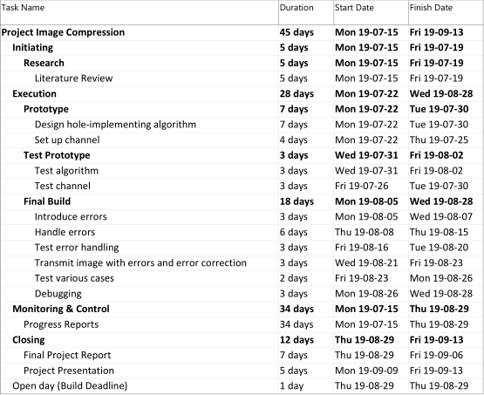

1. Conclusion